Manual calculation verification for the last updated maximum values with respect to date and hour

Account id = 410947164 .

Filtered the maximum number of messages per day with respect to hour in the active table and compared it with the behavior table . Max and Min is matching with respect to all Thursday, Friday and Monday for the active and behavior table.

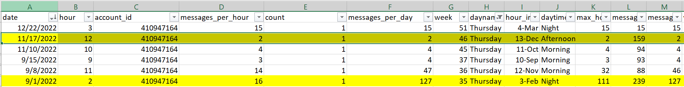







Account id = 408418225 .

Filtered the maximum number of messages per day with respect to hour in the active table and compared it with the behavior table . Max and Min is matching with respect to all Thursday, Friday and Monday for the active and behavior table.

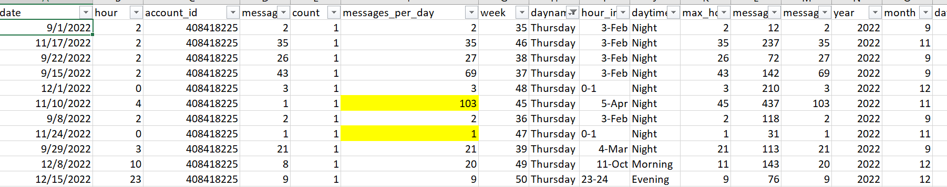

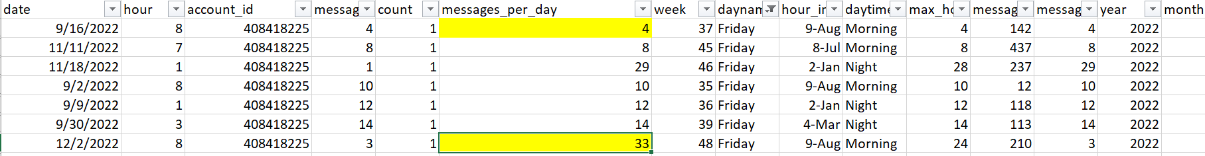

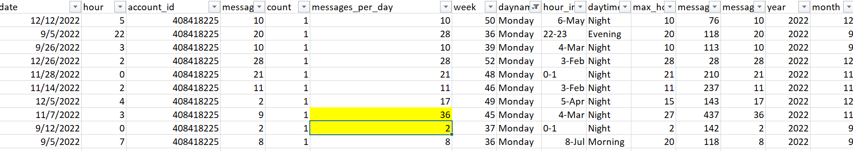

Behavior table



